

University of Central Punjab - Faculty of Information Technology Human Computer Interaction
Fall 25
PD Phase 1 (Group Work) PROJECT TITLE
Due Date: 12-11-2025 (via portal) Total Marks: 100 (70 Document +30 Viva)

CLO# | Course Learning Outcome (CLO) | Taxonomy Level | Mapping to PLO
CLO 2 | Understand elements of good and bad design, user  centric interactions and principles of innovation in realm of interactive design. | C3 | 3

Name | Registration Number | Section
Aswad Khan | L1F23BSSE0328 | SEE6
Zohaib | L1F23BSSE0326 | SEE6
Muhammad Arham | L1F23BSSE0372 | SEE6
.
Guidelines
- Add this Title Page with your submitted report. Violation will result in deduction of 5 marks.
- Group members of project can work together. Only group leader will submit the report on portal.
- Be careful about font structure and alignment of text. Violation will result in deduction of 5 marks.
- There is a strict policy against plagiarism and cheating. The penalty can be an F grade. Properly cite and refer the content wherever required. Violation will result in deduction of 5 marks.
- Your report will be judged on the following rubrics.
  - Completeness: Don't omit a dimension of usability, and don't overlook an obvious usability issue that even the reader notices.
  - Depth: "Efficiency is good, because it feels fast to use" is not deep analysis. "I've never made any errors with it" is not deep analysis.
  - Clarity: The reader should not struggle to understand what you're talking about.
  - Usability of presentation: Your report is itself a user interface whose purpose is to convey ideas to a reader. If your report is not readable then it will be harder for the reader to use, and it will not demonstrate an ability to apply the ideas of this class.

Smart Cafe
Abstract
Smart University Café is a mobile-first, campus-exclusive food ordering platform designed to eliminate long queues, reduce waiting time, and streamline cafeteria operations for university students, teachers, and administrative staff. Traditional café systems rely entirely on manual ordering, leading to crowding during peak hours, communication mistakes, delays, and overall dissatisfaction. This system modernizes the cafeteria workflow by enabling users to browse categorized menus, pre-order food items, schedule pickup time-slots, receive live order status updates, and collect their food efficiently using QR-based verification.
In addition to core ordering functionalities, Smart University Café introduces several enhanced features: Favorites & Quick Reordering, Scheduled Pickup Windows, Estimated Wait Time & Queue Position, Secure University-ID Login, Order Notifications, and a Post-Pickup Feedback System. These features align with key HCI usability goals such as learnability, efficiency, satisfaction, error prevention, and memorability, ensuring that users interact with the system smoothly and intuitively.
Designed specifically for campus environments, the platform improves service speed, reduces cafeteria congestion, minimizes operational errors, and ensures transparent communication between users and cafeteria staff. Ultimately, Smart University Café elevates the overall dining experience by offering a convenient, reliable, and user-centered digital ecosystem tailored for modern university life.

1. Introduction
Smart University Café is a dedicated online system designed to simplify and modernize the food-ordering experience within a university environment. The platform allows students, teachers, and staff to order food digitally, schedule pickup slots, and collect their orders once prepared—removing the need to physically stand in long queues. The aim is to address time constraints, peak-hour congestion, and inefficiencies in manual cafeteria workflows.
The system integrates essential features such as secure user login, menu browsing, real-time order tracking, QR-code verification, and push notifications. By combining modern usability principles with practical food-service requirements, Smart University Café ensures a reliable and efficient experience for both customers and cafeteria staff.
The platform tackles ongoing challenges faced by the campus community, enhances service management, and supports a smoother daily routine for busy university users.

1.1. Idea Generation
During the initial phase of the project, our team conducted an idea generation session to identify potential application concepts. Each member proposed at least one idea based on individual interests and observed problems. The ideas were then discussed and evaluated to select the most suitable project for development.

Ideas Proposed by Team Members
- Aswad: Smart University Café:A mobile-first platform allowing students and staff to pre-order meals, schedule pickups, and receive real-time notifications.
  - Rough storyboard sketch:
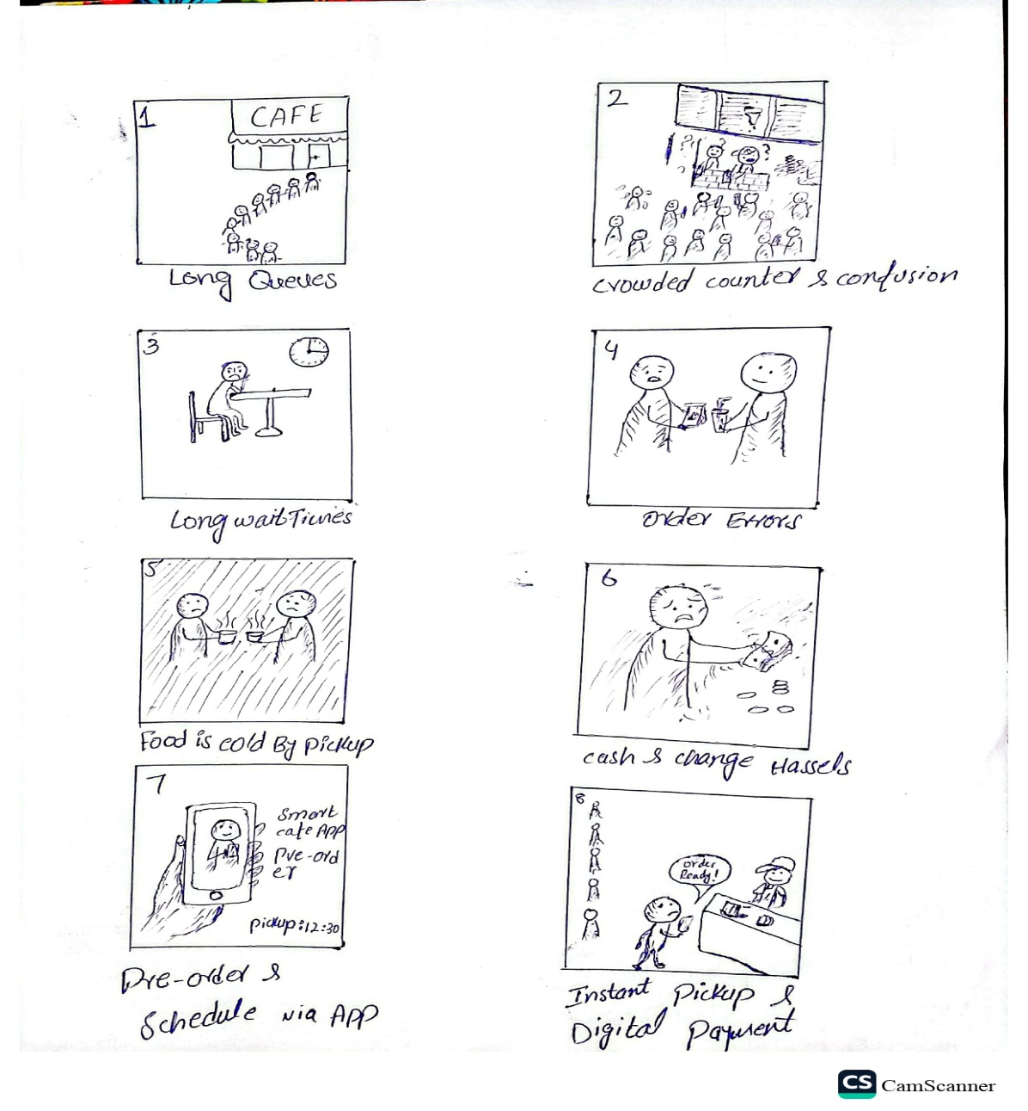

  - Limitation: Too common; many similar apps already exist.
- Arham: Food Delivery Tracker: An app to track food delivery status in real time.
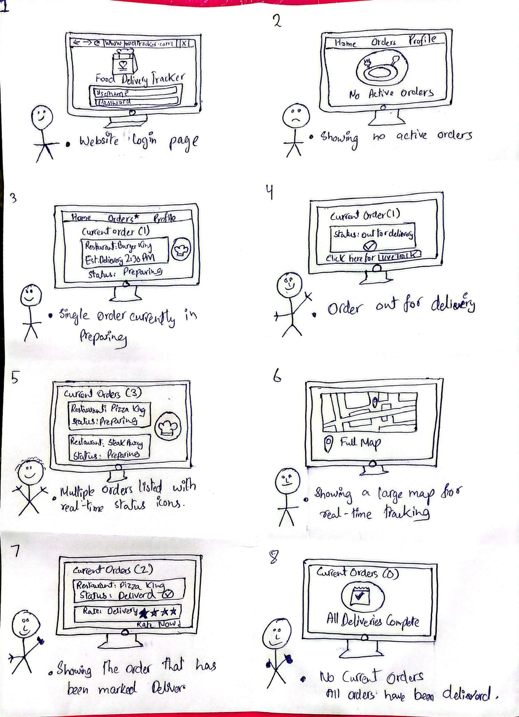
  - Rough storyboard sketch:

  - Limitation: Limited user engagement; may not attract enough active users initially.
- Zohaib: Fitness Goal Tracker: An app to log workouts and track fitness goals.
  - Rough storyboard sketch:
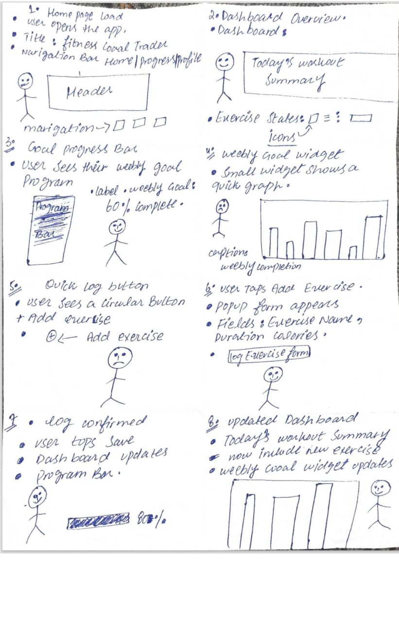
  - Limitation: Many existing solutions; lack of innovation.

Brainstorming Activity
Our brainstorming session followed these steps:
- Individual Idea Generation: Each member listed problems or potential applications based on personal interest and observed gaps.
- Presentation and Discussion: Each member presented their idea along with a rough storyboard sketch.
- Evaluation: Ideas were evaluated based on originality, feasibility, potential impact, and alignment with team skills.
- Selection: After discussion, the team voted on the most promising idea.

Selected Idea
The team selected Smart University Cafe as our project idea due to the following reasons:
- Originality: Offers a unique campus-specific pre-ordering and pickup system not currently available.
- Feasibility: Matches our team’s technical skills and can be developed within the project timeline.
- Potential Impact: Reduces cafeteria queues, saves user time, and improves overall service efficiency.
- Rejection of Others: Other ideas were either too common, had low impact, or required resources beyond our project scope.

1.2 Problem Statement
University cafeterias often experience long queues during breaks, causing delays and frustration for students and staff. The existing manual ordering process limits efficiency, increases waiting time, and creates uncertainty regarding order status. Users lack visibility into preparation time, resulting in overcrowding at counters and missed class schedules.
Who: University students, faculty, and staff who regularly use the cafeteria.
What: Long queues, slow processes, miscommunication, and lack of real-time updates.
When: Peak hours—before/after classes, lunchtime, and exam seasons.
Why: Manual processes, no tracking system, no scheduling, no notifications.
Where: All university cafeterias, food stalls, and beverage counters.
Goal / Desired State: A digital, user-centered platform that enables:
- Queue-free food ordering
- Real-time order tracking
- Scheduled pickup time-slots
- QR-verified pickup
- Notifications for order status
- Faster, more accurate service

1.3 Objectives
The Smart University Cafe project aims to modernize and enhance the on-campus food experience by introducing a streamlined, efficient, and user-centered digital system for students, faculty, and staff. The key objectives of the project are as follows:
- Digitize cafe services: Develop a centralized platform where users can view menus, check food availability, explore deals, and access updated cafe information in real time.
- Reduce waiting time: Provide features such as online ordering, pre-booking, and queue management to minimize crowding and long waiting lines at the cafe.
- Enhance operational efficiency: Facilitate smoother order handling, inventory tracking, and staff coordination to improve the overall workflow of the cafe.
- Ensure transparency and reliability: Display accurate prices, estimated preparation times, and order status updates to build trust and clarity for all users.
- Provide a user-friendly interface: Design a simple, intuitive, and responsive interface that allows users to navigate the platform seamlessly across different devices.
- Support personalized experiences: Enable users to save their favorite meals, receive notifications for order updates, deals, or new menu items, and maintain a personalized activity history.
- Promote hygienic and organized food service: Reduce physical crowding and miscommunication by shifting to a structured, digitally managed system.
- Improve accessibility of cafe services: Make it easier for all university members—including busy students and faculty—to access cafe offerings quickly and conveniently.
- Encourage digital transformation on campus: Contribute to a smarter university environment by replacing traditional manual cafe processes with an efficient, technology-driven model.

1.4 Motivation
Students and teachers consistently face delays due to cafeteria rush, especially between lectures. The difficulty of managing food preparation manually often results in incorrect orders, confusion, and wasted time. Several team members personally experienced being late for class because of café queues.
This motivated the idea of a system that saves time, improves service quality, and reduces frustration. The team wanted a solution that benefits the entire campus community and is used many times per day—maximizing impact.
HCI usability theory emphasizes designing systems that reduce user effort and enhance efficiency, making Smart University Café a strong, practical, and impactful project.

2. Target Market Identification
The target market for the Smart University Cafe includes all individuals within the university environment who regularly depend on cafeteria services, primarily university students, faculty members, administrative staff, and campus visitors. These users typically range from ages 18 to 55 and require a convenient, reliable, and time-efficient system to access food and beverages during their busy schedules. Students look for quick service between classes, faculty members prefer organized and predictable order handling, and staff rely on timely access during limited breaks, while visitors appreciate a simple way to view the menu and place orders without confusion. Overall, the target market consists of tech-aware, time-sensitive users who seek improved speed, transparency, and convenience in their everyday cafe experience.
Key Characteristics of the Users:

1. Age Group and Demographics
- The primary users include university students, faculty members, and administrative staff aged 18–55, representing a diverse academic community.
- Students form the largest user group, consisting of teenagers and young adults who frequently rely on the cafe for daily meals and refreshments.
- Secondary users may include visitors, parents, or guests who occasionally use cafe services while on campus.

2. Dining Behavior and Preferences
- Students often seek quick, affordable meal options due to tight class schedules and limited breaks.
- Faculty and staff prefer reliable, accurate, and timely service to manage teaching hours, office responsibilities, and meetings.
- Many users check menus in advance, compare prices, and look for convenient meal choices that suit their routine.
- Users may prefer pre-ordering to avoid queues, especially during peak hours such as lunchtime.

3. Tech-Savviness
- Most users are comfortable interacting with digital systems and online platforms due to regular exposure to academic portals and campus technology.
- They expect simple navigation, quick loading times, and a clean interface that supports fast interactions.
- Users value features like menu filtering, real-time updates, order tracking, and digital notifications.

4. Geographical Context
- The users are located within the university campus, often moving between classrooms, libraries, labs, and administrative buildings.
- Accessibility matters greatly, as users rely on efficient food services without needing to leave campus.
- Remote access (e.g., viewing menus or placing orders before reaching the cafe) is beneficial for users planning their meals during busy hours.

5. User Needs and Pain Points
- Reduced waiting time: Long queues and delays during peak hours create frustration and inefficiency.
- Menu clarity and availability: Users often face confusion regarding available items, prices, or out-of-stock dishes.
- Order accuracy: Miscommunication between staff and customers results in incorrect or delayed orders.
- Convenience: Users want a structured system to pre-order, track orders, and receive updates without standing in line.
- Transparency: Clear pricing, preparation time estimates, and real-time order status increase user trust and satisfaction.

6. Behavioral Traits and Motivation
- Users are highly time-conscious and prefer solutions that save effort and streamline their daily routine.
- Students are motivated by convenience and affordability, while faculty and staff prioritize reliability and speed.
- Users appreciate hygienic, organized, and predictable service experiences.
- They value digital efficiency that reduces unnecessary physical waiting and avoids miscommunication.

7. Market Potential
- University campuses experience heavy daily traffic at cafeterias, creating a strong demand for a modern, technology-driven food management system.
- Increasing digital adoption among students and staff makes the Smart Cafe concept highly feasible and impactful.
- A centralized digital system can significantly improve campus life by reducing congestion, improving service flow, and enhancing overall user satisfaction.

2.1 Target Market
The target market for the Smart University Cafe consists of university students, faculty members, administrative staff, and campus visitors who regularly rely on the cafeteria for meals and beverages. These users range roughly from ages 18 to 55 and share a common need for quick, convenient, and well-organized food services due to busy schedules and limited break times. Students require fast access between classes, faculty members prefer efficient ordering to manage teaching commitments, and staff depend on timely service during short breaks. Visitors also benefit from a simple and understandable system. Overall, the target market includes all individuals within the university environment who seek improved speed, reliability, and transparency in their everyday cafe interactions.
Detailed Characteristics of the Target Market:
Demographics:
- Age: The primary age group ranges from 18 to 55 years, covering undergraduate students, postgraduate students, teaching faculty, and staff members who actively visit the university cafeteria.
- Occupation: Students and university employees who rely on campus meals/snacks during their academic or working hours.
- Gender: Inclusive of all genders, as all have equal access and usage of campus food services.
- Education Level: All individuals associated with higher education institutions, possessing sufficient digital literacy to use mobile applications.
Psychographics:
- Users value time efficiency, wishing to avoid long queues especially during short class breaks.
- They prefer technology-supported convenience, such as mobile pre-ordering and real-time updates.
- Strong motivation for accurate service, including availability and preparation time.
- They seek stress-free cafeteria experience with reliable pickup timing.
- Users appreciate easy reordering, notifications, and consistency in dining routines.
Behavioral Traits:
- Frequent cafeteria visits — multiple times a day during busy schedules.
- Comfortable using smartphones, mobile apps, QR scanning, and cashless options.
- They often face challenges like overcrowding, miscommunication and delayed service, which leads to frustration.
- Users show high willingness to adopt solutions that save time, especially during peak hours.
- They plan food decisions based on next lecture timing, current crowd level, and food readiness.
Geographical Focus:
- Primary audience is within the university campus where cafeteria counters are located.
- Designed for cafeterias, tuck shops, beverage counters and all internal food stalls.
- System operates within secure campus premises where pickup is convenient and supervised.
- Scalable to multiple university campuses in the future.
Needs and Preferences:
- A queue-free ordering experience to avoid long waiting times.
- Ability to schedule pickup slots to better manage lecture timings.
- Real-time order tracking to check status updates from anywhere on campus.
- Support for cash on pickup + optional demo online payment.
- Favorites and quick reorder to minimize time spent in app.
- Clear availability of menu items to avoid last-minute disappointment.
- Reliability, transparency, and secure authentication using university ID.
- Notification alerts to ensure users never miss order readiness status.

Market Potential:
- 100% of campus population depends on cafeteria services daily → High adoption rate expected.
- Current system is completely manual and inefficient → Huge improvement opportunity.
- No existing built-in digital food ordering inside the university → First-mover advantage.
- Helps both service providers and customers by improving order management, traffic flow, satisfaction and timing discipline.
- Strong potential for future expansion:
  - Meal subscriptions
  - Multiple vendor integration
  - Performance analytics for admin
By focusing on this well-defined target market, Smart University Café directly addresses the real needs and everyday challenges faced by students and university staff. It provides a simple, efficient, secure, and reliable cafeteria experience. Understanding the demographics, psychographics, behaviors, and preferences ensures the system remains relevant, user-friendly, and highly impactful in improving the campus dining environment.

2.2 User Classes and Characteristics
Based on the target market identified for Smart University Café, the system anticipates multiple classes of users. These classes differ in terms of frequency of cafeteria usage, interaction with digital services, access privileges, and tasks performed in the application. Users are also categorized as primary or secondary depending on whether they are directly involved in the ordering process or support the system from the operational side. Understanding these classes ensures proper UI design, usability optimization, and security control tailored for each type of user.

1. Students (Primary Users)
• Description: Most frequent café visitors who require fast and convenient ordering during short breaks.
• Frequency of Use: High; multiple times a week.
• Platform Functions Used: Menu browsing, placing orders, scheduling pickup, tracking status, favorites, notifications, payment, rating.
• Technical Expertise: Intermediate; familiar with mobile apps and QR codes.
• Security/Privileges: Standard verified account using Registration Number; full access to ordering features.
• Characteristics: Motivated by saving time, avoiding queues, and ensuring timely food pickup before/after classes.

2. Teachers / University Staff (Primary Users)
• Description: Users with limited break durations who value precise timing and guaranteed pickup readiness.
• Frequency of Use: Moderate; depending on work schedule.
• Platform Functions Used: Quick ordering, scheduled pickup, tracking, notifications, rating.
• Technical Expertise: Intermediate to advanced; regularly use campus digital platforms.
• Security/Privileges: Verified account using Staff ID; full ordering privileges.
• Characteristics: Time-sensitive, prefer reliable and efficient service with minimal waiting.

3. Cafeteria Staff (Secondary Users)
• Description: Backend users handling food preparation and updating order statuses.
• Frequency of Use: Continuous during operational hours.
• Platform Functions Used: Accept orders, update preparation progress, mark ready, verify QR codes upon pickup.
• Technical Expertise: Basic to intermediate; require a simple and quick interface.
• Security/Privileges: Staff panel access; restricted to operational controls.
• Characteristics: Focused on speed, accuracy, and workflow management; require reduced counter congestion.

4. Cashier / Counter Staff (Secondary Users)
• Description: Handle cash payments and order completion verification.
• Frequency of Use: Continuous during café hours.
• Platform Functions Used: Payment confirmation, QR scanning, marking order as complete.
• Technical Expertise: Basic; trained for app usage.
• Security/Privileges: Limited backend privileges; order status control only.
• Characteristics: Need fast and error-free verification to maintain smooth pickup flow.

5. System Administrator (Secondary User)
• Description: Manages the system settings, menu, user accounts, and overall platform security.
• Frequency of Use: Periodic and supervisory.
• Platform Functions Used: Menu management, item availability, user verification, monitoring, reporting, issue handling.
• Technical Expertise: Advanced; knowledge of administrative configuration.
• Security/Privileges: Highest access level; controls application parameters and data security.
• Characteristics: Ensures platform integrity, operational stability, and user satisfaction.

6. New / First-Time Users
• Description: Users accessing the system for the first time without previous usage experience.
• Frequency of Use: Low initially — increases as familiarity and trust build.
• Platform Functions Used: Registration, trial browsing, initial order attempt, guided steps.
• Technical Expertise: Basic; may require onboarding instructions.
• Security/Privileges: Restricted access until account verification; user guidance enabled.
• Characteristics: Curious but cautious; require intuitive UI and confidence-building notifications.

2.3 Primary and Secondary User Classes
The Smart University Café application categorizes its users into Primary and Secondary classes based on their main involvement in the food ordering workflow. This classification ensures that each user receives the appropriate interface design, feature access, and usability experience based on their role and frequency of interaction. Primary users directly engage in placing and collecting food orders, while secondary users operate and support backend processes to ensure seamless café service.

Primary Users
Core users who frequently place food and beverage orders.
User Classes:
- Students: Regular cafeteria visitors who order during breaks and need fast service.
- Teachers / University Staff: Time-sensitive users who rely on scheduled pickup options.
- New / First-Time Users: Users exploring the app for the first time and learning the ordering process.
- Frequent Buyers: Users who consistently order and utilize favorites/quick reorder features for convenience.
Tasks of Primary Users:
• Browsing menu categories and item details
• Adding items to cart and placing orders
• Selecting ASAP or scheduled pickup slots
• Tracking food preparation status updates
• Receiving notifications for acceptance and readiness
• Paying via Cash on Pickup or demo online payment
• Collecting food through QR code verification
• Giving ratings and feedback after pickup

Secondary Users
Secondary users support and facilitate the platform rather than engaging in core food ordering activities. They are responsible for smooth service delivery, order accuracy, and maintaining platform availability.
User Classes:
- Cafeteria Kitchen Staff: Preparing food items and updating order status throughout the workflow.
- Cashier / Counter Staff: Verifying QR codes, confirming payments, and marking orders completed.
- System Administrator: Managing menu, users, availability flags, issues, and platform integrity.
Tasks of Secondary Users:
• Confirming and managing incoming orders
• Updating order status (Pending → Accepted → Preparing → Ready → Completed)
• Verifying customers via QR scanning at pickup
• Ensuring menu accuracy and item availability
• Monitoring system usage and resolving operational issues
• Maintaining service speed, security, and trust

Justification for Separate Classes
Separating users into primary and secondary classes allows Smart University Café to prioritize usability and convenience for those placing orders while providing efficient operational tools for staff managing café workflows. Primary users require fast navigation, reliable tracking, and secure pickup, whereas secondary users require simple and efficient order management and verification systems. This separation enhances user satisfaction, reduces cafeteria congestion, and ensures smooth platform operation without task confusion.

3. Exploratory Study

3.1 Analysis
To understand the necessity and impact of Smart University Café, it is important to analyze the current systems used for food ordering within the university environment, whether manual or partially digital. This analysis highlights strengths, weaknesses, and gaps that our system aims to resolve.

Existing Systems

1. Manual Cafeteria Ordering (Current University System)
Strengths:
▪ Familiar and easily accessible to all users
▪ Direct human interaction with staff
▪ No digital skills required
Weaknesses:
▪ Long waiting lines during peak hours
▪ No way to track order preparation status
▪ Higher chance of miscommunication or wrong orders
▪ Time-consuming process resulting in missed classes
▪ Overcrowding creates stress for both staff and users

2. Food Delivery Apps (Foodpanda, KFC)
Strengths:
▪ Digital ordering and payment convenience
▪ Real-time order tracking
▪ Visual menu with prices and availability
▪ Notification alerts for order status
Weaknesses:
▪ Not designed for on-campus pickup
▪ Delivery fee increases total cost
▪ Unable to schedule pickup slot based on class timings
▪ Often slower due to delivery logistics
▪ No cafeteria load-based ETA

3. Pre-booking via Calls / Informal WhatsApp Orders
Strengths:
▪ Allows ordering without standing in queue
▪ Familiar communication method
Weaknesses:
▪ No systematic time-slot management
▪ Staff may forget or wrongly note orders
▪ No availability checks → leads to disappointment
▪ Unorganized and difficult to track during rush hours

Novelty and Meaningfulness of Smart University Café
Smart University Café introduces a university-focused pre-ordering system that merges digital convenience with on-campus accessibility. Unlike general delivery apps or current manual processes, this system is:
▪ Designed specifically for students and staff
▪ Eliminates the need for queues entirely
▪ Ensures accurate timing with scheduled pickups
▪ Provides real-time status updates (Pending → Preparing → Ready)
▪ Uses QR verification for fast pickup without confusion
▪ Improves cafeteria workflow and staff productivity
▪ Reduces stress and waiting frustration
▪ Guarantees secure login using University ID only
The novelty lies in combining menu browsing, order tracking, QR-based pickup, and academic schedule alignment into a single mobile-first solution. This makes the system meaningful, user-centered, and impactful by addressing:
- Long queues
- Service uncertainty
- Time loss during breaks
- Manual preparation overload
Result: A smooth, reliable, organized campus dining experience for everyone.

3.2 Usability Goals
Usability goals define how effectively, efficiently, and satisfactorily users interact with a system. For Smart University Café, these goals ensure a smooth, intuitive, and reliable experience for both primary and secondary users while minimizing stress during peak cafeteria hours.

Initial List of Usability Criteria

1. Ease of Navigation
o Users should easily browse menu categories, view item details, and place orders without confusion.
o Clear icons, categorized food listings, and simple step-by-step order flow are essential.

2. Learnability
o First-time users should quickly understand how to register, order, choose pickup slots, and track status.
o Guided prompts, simple UI, and onboarding screens support fast learning.

3. Efficiency of Use
o Frequent users should perform regular tasks quickly with minimal steps.
o Features like favorites, quick reorder, saved pickup preferences, and auto-filled instructions enhance efficiency.

4. Error Prevention and Recovery
o The system should minimize order mistakes (wrong time-slot, unavailable items).
o Pop-ups, clear alerts, restricted invalid inputs, and easy cancellation support recovery.

5. Memorability
o Returning users should easily remember how to place an order after not using the app for a few days.
o Consistent icons, standard layouts, and familiar flow ensure smooth recall.
o Measured by tracking how fast returning users complete key tasks without help.

6. Security and Trust
o Users must feel confident that their personal data and payments are safe.
o University ID–based registration and secure payment handling maintain trust.

7. User Satisfaction
o The overall experience should feel smooth, dependable, and stress-free.
o Fast ordering, real-time updates, and queue-free pickup improve satisfaction.

High-Level Evaluation Approach

1. Test Participants:
o Select a sample of primary users (students, teachers) and secondary users (cafeteria staff).

2. Tasks for Evaluation:
o Browsing menus and selecting food items
o Placing orders with pickup slot selection
o Tracking order status
o Making payment and completing pickup
o QR code scanning + rating submission

3. Evaluation Methods:
o Observation: Track difficulties during real task execution
o Surveys / Questionnaires: Collect feedback on usability and satisfaction
o Time-on-Task Metrics: Measure how long ordering takes
o Error Rate Tracking: Count mistakes in order placement and pickup
o Memorability Test: Have users repeat tasks after a gap to assess recall

Measuring Successful Adherence to Goals
• Ease of Navigation: ≥ 85% of users complete ordering without assistance
• Learnability: First-time users place an order in ≤ 3–4 minutes
• Efficiency of Use: Favorites/quick reorder tasks completed in ≤ 1–2 minutes
• Error Prevention & Recovery: Very low error rate; users recover independently
• Memorability: ≥ 80% of returning users perform tasks smoothly without training
• Security & Trust: High trust feedback; successful login/authentication without issues
• User Satisfaction: Average satisfaction score ≥ 4/5 on usability survey

4. Need Findings (Interviews)

4.1 Interviews
Before starting each interview, a complete and structured introduction was delivered to ensure consistency, ethical transparency, and user comfort. The introduction helped clarify the purpose of the activity and provided interviewees with relevant context about the project.

1. Self-Introduction
“Hello, my name is (Muhammad Arham), and I am a Software Engineering student at the University of Central Punjab. As part of our Human-Computer Interaction (HCI) course, we are conducting a user research activity that involves interviewing university users to understand their needs, behaviors, and challenges related to food ordering within the campus cafeteria environment.”

2. Purpose of the Interview
“The purpose of this interview is to collect real user feedback that will help us design a more accurate, user-friendly, and meaningful solution. Your insights will help us understand the difficulties people face while ordering food during rush hours, and how we can improve the cafeteria experience to better support your daily routine.”

3. Brief Introduction of Smart University Café
“Our project, Smart University Café, is a mobile-first platform created specifically for university students and staff. The core idea is to allow users to pre-order food from the campus cafeteria, choose a suitable pickup time-slot, track their order in real-time, and collect it through a QR code system. The goal is to eliminate long queues, reduce waiting time, and enhance dining convenience for the entire campus community.”

4. Reassurance Regarding Ethics, Privacy, and Data Rights
“Before we start, we assure you that this interview is completely confidential. Your name, personal information, and responses will not be made public. All collected data will only be used for academic analysis in this HCI project. You have full freedom to skip any question or stop the interview at any time if you feel uncomfortable.”

5. Request for Recording Permission
“For documentation purposes, we would like to record this interview. The recording will only be used privately within our course requirements and stored securely — it will not be shared publicly. Do you give us permission to record this interview?”

6. Collecting Basic User Details
“Before continuing, could you please share your name, your role at the university (student or faculty), and your daily cafeteria usage? This will help us understand your user group and the context behind your responses.”
This introduction was consistently delivered to every interviewee to maintain professionalism, clarity, and fairness throughout the need-finding process.

Main Interview Questions
(Primary Users)
After the introduction, the following open-ended questions were asked to the interview participants:
- Can you tell me a little bit about your normal day at the university and when you usually go to the cafeteria?
- Could you describe what usually happens when you go to buy food during your break time right now?
- How do the long lines at the cafeteria affect your classes or your free time?
- Imagine you could choose a specific time to pick up your lunch while you are still in class. How would that change your daily schedule?
- How would you feel if you could see exactly when your food is being cooked on your phone instead of standing at the counter to check?
- What are your thoughts on showing a code on your phone to grab your food quickly instead of waiting for a receipt or your name to be called?
- When you are deciding what to eat, what information is usually missing or hard to find, and what would you like to see on a digital menu?
- If you often eat the same thing, how would you like an app to help you order it faster the next time?
- What would the app need to do to make you feel safe and comfortable trusting it with your lunch order?
- Just to wrap up, what is the one snack or meal at the cafeteria that you really wish was always available and never ran out of stock?
(Secondary Users)
- Can you describe what a typical busy day looks like for you while working in the cafeteria kitchen or at the counter?
- When the cafeteria gets extremely crowded during lunch, what is the most difficult part about managing all the orders coming in at once?
- How do you currently keep track of which order belongs to which student, and what happens if an order gets mixed up?
- What do you think about having a screen in the kitchen that shows you exactly what to cook and in what order, instead of relying on verbal requests?
- How would it change your workflow if you could notify a student their food is ready just by tapping a button, instead of having to shout their name?
- If you could see all of the orders that need to be ready for a specific time slot in advance, how would that help in preparing food?
- What are your thoughts on using a QR scanner to confirm a student’s order instead of checking paper receipts or asking verbally?
- What issues do you sometimes face when trying to confirm if a student has completed payment during busy hours?
- How do you think it would affect the crowd at the counter if students only approached once they received a notification that their food is ready?
- To end on a lighter note, which popular item keeps you the busiest during rush hours?

Closing
At the end of the interview, we used the following closing remarks:
• “Thank you very much for your valuable time and feedback.”
• “Your responses will directly help us improve the design and usability of this application.”
• Thank you so much for taking the time to speak with me during your busy schedule.
4.2 User Photos and Captions
Primary Users (Gamers)
User Type | Description | Goals
Primary User 1: Student | Picture not taken, description provided. A university student who frequently visits the cafeteria during short class breaks and needs fast service. | -Order food quickly without waiting in long queues.
Primary User 2: Lecturer / Teaching Staff | Picture not taken, description provided. A teacher with limited break time and strict schedule. | -Ensure food is ready exactly on time.  Prefer scheduled pickup and reliable service.
Secondary Users (Sellers)
User Type | Description | Goals
Secondary User 1: Cafeteria Kitchen Staff | Picture not taken, description provided. Handles food preparation and updates order status in the system. | - Upload ads easily.- Connect with targeted buyers.- Build trust with ratings/verification.
Secondary User 2: Cashier / Counter Staff | Picture not taken, description provided. Verifies order pickup and receives payment if required. | - Sell items quickly and safely.- Get fair pricing.- Deal with verified nearby buyers.

4.3 User Needs

User Needs Extracted from Interviews

Primary User 1 — Student (5 User Needs)
- Needs to avoid waiting in long cafeteria lines. (common)
- Needs real-time updates on order status. (common)
- Needs scheduled pickup slots that match class breaks.
- Needs quick reordering of frequently bought items.
- Needs a reliable way to ensure their order is correct and available.

Primary User 2 — Lecturer / Teaching Staff (5 User Needs)
- Needs a fast and predictable service without delays. (common with Primary User 1)
- Needs notifications when the order is ready to avoid unnecessary waiting. (common)
- Needs an easy-to-use app interface requiring minimum time/effort.
- Needs food preparation to align with teaching schedule.
- Needs accurate pickup verification to avoid mistakes.

Secondary User 1 — Cafeteria Kitchen Staff (5 User Needs)
- Needs an organized list of pending and active orders. (common among staff)
- Needs ability to update food status quickly. (common)
- Needs workload visibility to avoid kitchen overload.
- Needs to minimize communication errors with customers.
- Needs more efficient workflow to keep operations smooth.

Secondary User 2 — Cashier / Counter Staff (5 User Needs)
- Needs a fast QR verification process for order pickup. (common with kitchen staff operational needs)
- Needs confirmation that payment is completed or pending.
- Needs a clear display of user order details to avoid mix-ups.
- Needs reduced crowding at pickup counter.
- Needs proper task flow that reduces stress during peak times.
4.4 Class Profiles
Primary User (Students)
Category | Details
Age: | 17–25 years (Average: 21 years)
Gender: | 55% male – 45% female (varies by campus)
Role / Job Titles: | Undergraduate student, Postgraduate student
Experience Level: | 1–4 years of university life
Work / Study Hours: | 4–6 classes per day; cafeteria visits during short breaks
Education: | University level — currently pursuing a degree
Location: | On-campus within the university (day scholars)
Income / Allowance: | PKR 5,000–20,000 per month (Depends on family support & part-time income)
Technology Skills: | Comfortable using smartphones, QR scanning, mobile apps
Disabilities: | No specific limitations (special accommodations available if needed)
Family Status: | Mostly unmarried; typically living with family or in hostel

Secondary User (Cafeteria Staff)
Category | Details
Age: | 25–50 years (Average: 35 years)
Gender: | Predominantly male
Job Titles: | Kitchen worker, Chef, Counter staff
Experience Level: | 2–15 years in food service industry
Work Hours: | 8–10 hours per day — peak hours during breakfast & lunch
Education: | Basic education to Intermediate level
Location: | On-campus work environment
Income: | PKR 20,000–45,000 per month (varies by role & experience)
Technology Skills: | Basic smartphone skills — need simple app UI for status updates
Disabilities: | No specific limitations — accessibility varies
Family Status: | Married or single (Predominantly married with children)

4.5 & 4.6. Personas and Scenarios
Primary User (Student)

1️.Header
Name: Muhammad Arham
Summary Quote: “I don’t want to waste my entire break standing in a queue. I just want to order, pick up, and go to class on time.”

2️.Demographic Profile (Based on User Research)

Personal Background

Muhammad Arham is a 21-year-old BSSE student at the University of Central Punjab. He lives in the university hostel and spends most of his day in classes, labs, and study sessions. He frequently eats at the campus cafeteria but often misses his chance to eat properly because of long queues and slow service. He relies on mobile apps for daily convenience and feels most comfortable using smartphone-based services.

Professional/Academic Background

Arham is a full-time student with no permanent job, although he occasionally tutors juniors to earn a small allowance. His monthly expenses are limited, so he prefers affordable and quick meal options. Because his breaks are short, he wants food services that match his fast-paced academic routine.

User Environment

Arham mainly uses his smartphone and laptop while staying connected to the high-speed campus Wi-Fi. He constantly moves between different buildings on campus, which means he needs a system that is mobile-friendly and accessible from anywhere. He sometimes hangs out with friends in the cafeteria but usually orders food individually due to time pressure during busy class hours.

Psychographics
He is motivated by convenience, speed, and well-organized workflows. He enjoys chai, fast snacks, and digital systems that simplify tasks. His frustrations include waiting in long queues, finding items out of stock after reaching the counter, and unpredictable delays that disrupt his schedule. He values clarity, reliability, and time management to reduce stress during the day.

3️.End Goal(s)
Arham wants to order food quickly from his phone, pick it up without standing in long lines, and ensure that his food is ready exactly when he arrives — allowing him to enjoy his break and reach his classes on time without rushing.

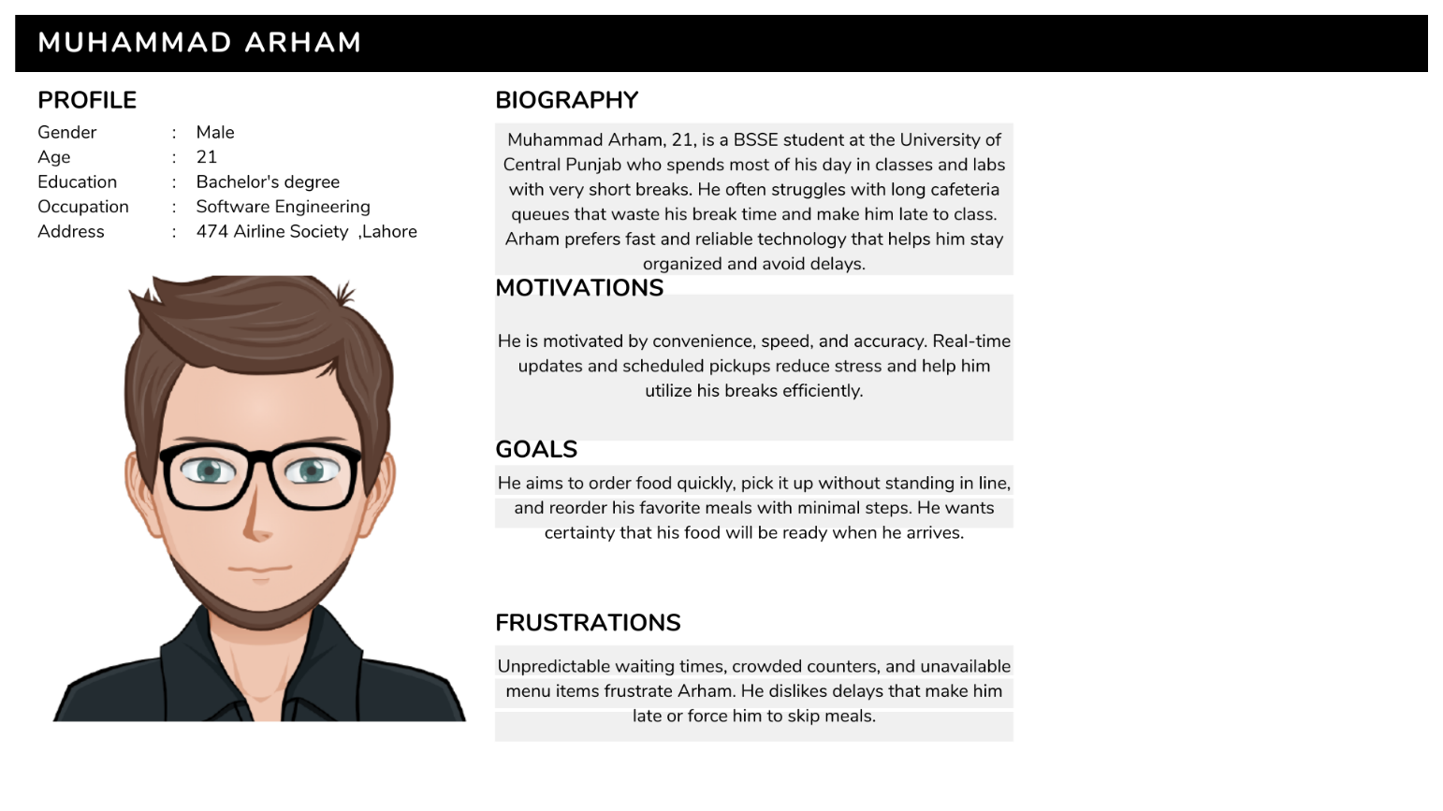
Scenario
AMuhammad Arham has just finished his programming lab and only has fifteen minutes before his next class begins. He feels hungry and wants to buy something from the campus cafeteria, but he already knows this is the busiest time of the day. In the past, he has had to choose between waiting in a long line or reaching class on time — and many times he skipped food entirely.
Instead of heading straight to the crowded cafeteria, Arham opens the Smart University Café app while walking outside the lab. He browses the menu quickly and selects fries and a cold drink. The app allows him to choose a scheduled pickup slot, so he selects the one that fits perfectly into his remaining break. The app shows the expected preparation time, which reassures him that he won’t have to wait.
Arham continues toward his next class building until he receives a notification saying his food is “Ready for Pickup.” He walks to the counter, scans the QR code shown on his phone, and collects his order instantly without standing in a queue. He then reaches his class on time, satisfied and stress-free.
Primary User (Teacher / University Staff)

1️.Header
Name: Sir Bilal Ahmed
Summary Quote: “My break is short. I need my food ready when I get there-not 10 minutes later.”

2️.Demographic Profile (Based on User Research)

Personal Background
Bilal Ahmed is a 34-year-old male lecturer from Lahore. He is married and has one young child. His daily schedule is structured around lectures, evaluations, and faculty meetings, leaving very limited free time. He belongs to the persona group of working professionals within the university campus.

Professional Background
Bilal is a full-time Computer Science faculty member at the university with a stable monthly income. His work experience spans more than 6 years. His available time for meals is short, and punctuality is his top priority due to continuous academic responsibilities.

User Environment
Bilal spends most of his time in his office, classrooms, and staff areas. He uses a smartphone and official laptop with strong campus network connectivity. He prefers apps that are simple, fast, and require minimal interaction. He rarely has time to stand in long lines or wait for food.

Psychographics
He is motivated by efficiency and professional discipline. He prefers structured services and expects accuracy in timing. He gets frustrated when delays disrupt his schedule or cause him to skip meals entirely. He appreciates technology that supports personal convenience and avoids crowd stress.

3️.End Goal(s)
He wants to pre-order lunch or tea, select a specific pickup slot, and collect food instantly upon arrival without delays ensuring he remains on schedule throughout the day.
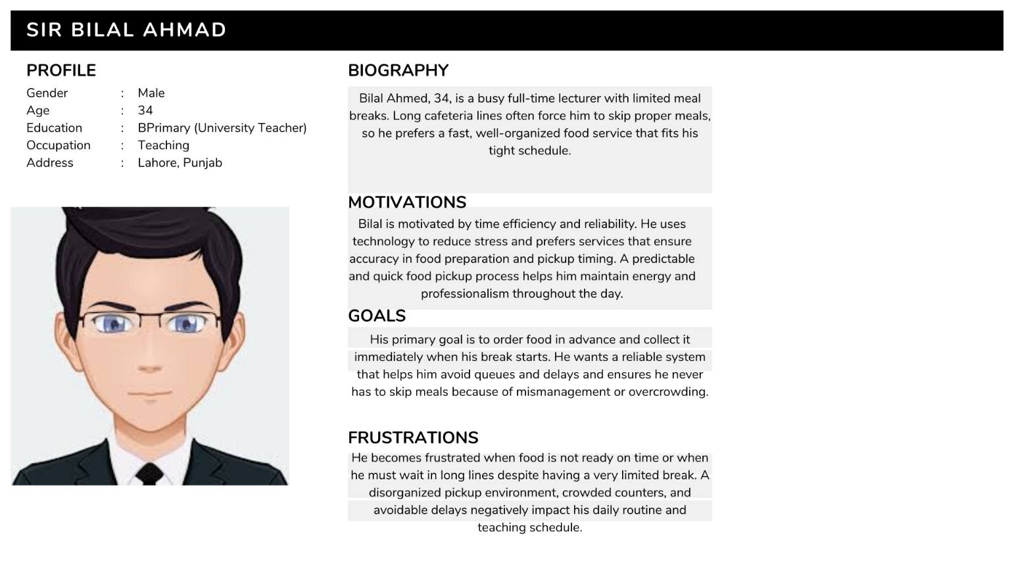
Scenario
Sir Bilal has a tight schedule filled with back-to-back lectures and a meeting lined up for later in the day. He has only a short break and wants to have a proper meal, but the cafeteria is usually crowded, and delays are common. He dislikes rushing and fears his food won’t be ready when he arrives.
Before finishing his current lecture, he quickly uses Smart University Café to place an order for a sandwich and coffee and selects a pickup window right after class ends. The system displays the expected preparation time, allowing him to plan calmly. As soon as he sees a notification that the order is ready, he walks directly to the counter, shows his QR code, and collects the meal within seconds. He then heads straight to his office to eat comfortably before his next commitment, without any interruption or wasted time.
Secondary User (Cafeteria Staff)

1️.Header
Name: Muhammad Imran
Summary Quote: “The easier the system is for us, the faster we can serve everyone.”

2️.Demographic Profile (Based on User Research)

Personal Background
Imran is a 38-year-old male living in Lahore with his wife and two children. He has been working in campus cafeteria services for several years. He belongs to the persona group of operational staff who ensure food preparation and service.

Professional Background
He works full-time as a kitchen staff member responsible for meal preparation and handling rush-hour orders. His income supports his family, and his job requires efficiency, teamwork, and handling multiple orders under pressure.

User Environment
Imran works in the cafeteria kitchen throughout the day. His interaction with technology is limited — he mainly uses a basic Android phone. The system he uses must be extremely simple, with large buttons, minimal reading, and quick status updates. His main focus is preparing food accurately and on time.

Psychographics
He is motivated by stable workflow and fewer customer complaints. He dislikes confusion, crowd noise, and repeated questions from waiting students. He wants the app to show orders clearly, helping staff manage tasks smoothly. His frustration rises when sudden rush, unclear orders, or mistakes create delays.

3️.End Goal(s)
Imran wants a clear and easy system to view incoming orders, update status when food is prepared, and help streamline service so there is less chaos and more satisfied users.
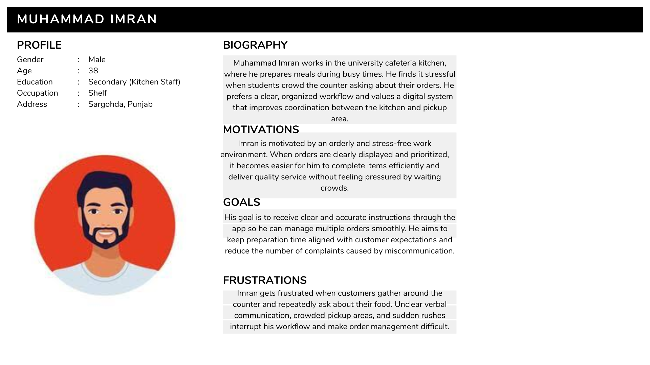
Scenario
Imran is working during peak lunch hour. The cafeteria receives many orders at once, often causing confusion about which orders to prepare first and who is waiting at the counter. Previously, handwritten order notes and verbal requests made it difficult to track item status, leading to mistakes and frustrated customers.
With Smart University Café, Imran can clearly see all incoming orders sorted by time and urgency. The app interface shows each order with the user’s chosen pickup slot, allowing him to prioritize preparation accurately. Once an order is ready, he marks it as “Ready for Pickup,” which sends a notification to the customer without anyone yelling over the counter. The workflow becomes smoother, there is less crowding, and he feels more in control. Customers receive their meals on time, and stress levels decrease for both staff and students.

